

Godia Ventures E-learning

Project Report

David Onuoha | MBI 630 | 10/4/2019

Table of Contents

1. Introduction
2. Planning Phase
   1. Background of Company
   2. Mission/ Objectives
   3. Business Problems
   4. Organizational Chart
   5. Feasibility Study
   6. GANNT Chart
3. Analysis Phase
   1. Document fact finding techniques, process and results (User requirement)
   2. Identify external entities (Context diagram)
   3. Identify major subsystems (level 0)
   4. Expand a subsystem and identify process (business process)
4. Design Phase
   1. ER diagram
   2. User case diagram
   3. Database Schema
   4. GUI design
   5. Input / Output design
5. Implementation
   1. Coding plan
   2. Testing
   3. Hardware / Software installation plan
   4. User training plan
   5. Go live
   6. Maintenance plan
   7. Future improvement
   8. Lessons learned

## SeCTION 1. Introduction

With the proliferation of technology such as smart phones, tablets and broad band internet, there is a change the way students are learning worldwide. One of the mandates of the sustainable developmental goal is to provide quality education all over the world. Difficulty in obtaining education can be due to various reasons. It could be their possible limit of capabilities with an educational environment or disabilities that limit their access to educational institutions. There are also a number of people that live a great distance from the educational institutions. The need to commute becomes an obstacle to achieving standard education. Also, the job markets are so competitive that employees find that they must obtain higher education for further employment success. Electronic learning programs are the solution to the above problems. The greatest appeal of distance learning is that one can study without having to leave home or a job to obtain education. These programs made it possible for students to complete their education without having to sacrifice their career and family time.

SECTION 2. PLANNING PHASE

2.1 Background of Company

At Godia ventures we are committed to education of young minds in Nigeria. Since inception of company in 1995, we have dedicated ourselves to running mentorship programs, providing educational materials and setting up libraries with internet capabilities in various schools all over the Nigeria. This is why our slogan is “Creating a brighter future, one child at a time”. Through our commitment to childhood education, we lead the way in providing educational materials, organizing symposia, mentorship programs and scholarship for school children. This is our way of contributing to achieve the sustainable development goals for quality education in the world by the year 2013.

* 1. Mission/ Objectives

The scope of this project is to establish an E-learning platform in one school as a test run of the acceptance of this new form of learning. The objective of this report/project is to design and implement a web-based system that allows interaction between instructors and students. This involves developing an intuitive user interface for both instructor and student. Instructors and students are the external entities to the system who can log into the system and use the functionality provided by the system. The instructors and the students enter the system through a login tool component. The additional objective of this project is to design a system with reusable components, feasibility and provision for system expansion without compromising system performance.

* 1. Business Problems

We noticed that a lot of communities in Nigeria lack functioning schools in their local districts. Most students have to travel long distances to attend classes and this in effect has added to the major cause of out of school kids in the country. In contrast to this issue, every one in the country owns a smart phone with internet access. Making E-learning a viable means of educating this target population.

* 1. Organizational Chart

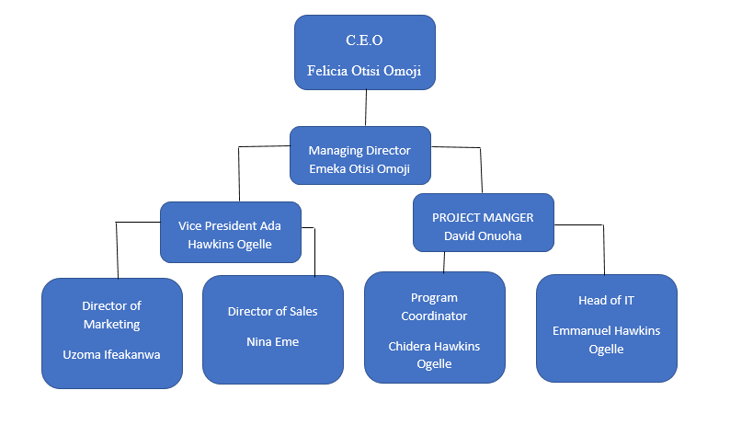

* 1. Feasibility Study

|  |  |  |  |  |  |  |  |
| --- | --- | --- | --- | --- | --- | --- | --- |
| GODIA VENTURES E-Learning | | |  |  |  |  |  |
| Economic Feasibility Analysis | |  |  |  |  |  |  |
| MBI 600 Project |  |  |  |  |  |  |  |
|  |  |  | Year of Project | |  |  |  |
|  | Year 0 | Year 1 | Year 2 | Year 3 | Year 4 | Year 5 | **TOTALS** |
| Net economic benefit | $0 | $350,000 | $350,000 | $350,000 | $350,000 | $350,000 |  |
| Discount rate (12%) | 1 | 0.8929 | 0.7972 | 0.7118 | 0.6355 | 0.5674 |  |
| PV of Benefits | $0 | $312,515 | $279,020 | $249,130 | $222,425 | $198,590 |  |
|  |  |  |  |  |  |  |  |
| NPV of all BENEFITS | $0 | $312,515 | $591,535 | $840,665 | $1,063,090 | $1,261,680 | **$1,261,680** |
|  |  |  |  |  |  |  |  |
| One-time COSTS | $200,000 |  |  |  |  |  |  |
|  |  |  |  |  |  |  |  |
| Recurring Costs | $0 | 140,000 | $140,000 | $140,000 | $140,000 | $140,000 |  |
| Discount Rate (12%) | 1 | 0.8929 | 0.7972 | 0.7118 | 0.6355 | 0.5674 |  |
| PV of Recurring Costs | $0 | $125,006 | $111,608 | $99,652 | $88,970 | $79,436 |  |
|  |  |  |  |  |  |  |  |
| NPV of All COSTS | 200,000 | $325,006 | $436,614 | $536,266 | $625,236 | $704,672 | **$704,672** |
|  |  |  |  |  |  |  |  |
|  |  |  |  |  |  |  |  |
| Overall NPV |  |  |  |  |  |  | **$557,008** |
|  |  |  |  |  |  |  |  |
|  |  |  |  |  |  |  |  |
| Overall ROI - (Overall NPV/ NPV of All COSTS) | | |  |  |  |  | **0.79** |
|  |  |  |  |  |  |  |  |
|  |  |  |  |  |  |  |  |
| Break-Even Analysis |  |  |  |  |  |  |  |
| Yearly NPV cash flow | $200,000 | $187,509 | 167,412 | $149,478 | $133,455 | $119,154 |  |
| Overall NPV cash flow | $200,000 | $12,491 | $154,921 | $304,399 | $437,854 | $557,008 |  |
|  |  |  |  |  |  |  |  |
| Project break-even occurs between years 1 and 2 | | |  |  |  |  |  |
| Use first year of positive cash flow to calculate break-even fraction - (167412 -154921)/167412 = 0.075 | | | | | | | |
| **Actual break-even occurred at 1.1 years** | | |  |  |  |  |  |

* 1. GANNT Chart

SECTION 3. ANALYSIS PHASE

* 1. Document fact finding techniques, process and results (User requirement)

This represents how the system works for the user (Student.).

A user must be registered before he can view contents of the course such as power point presentations, audio materials, videos and texts.

Course completion is not restricted by date or time and user can return to the course at any time.

Each time user needs to access this system, he/she has to log in using an user name and password.

After completion of a course, user is offered a quiz or assessment.

User needs to pass this assessment else the course will start from the beginning again.

On passing the assessment, user is offered a course completion certificate.

* 1. Identify external entities (Context diagram)

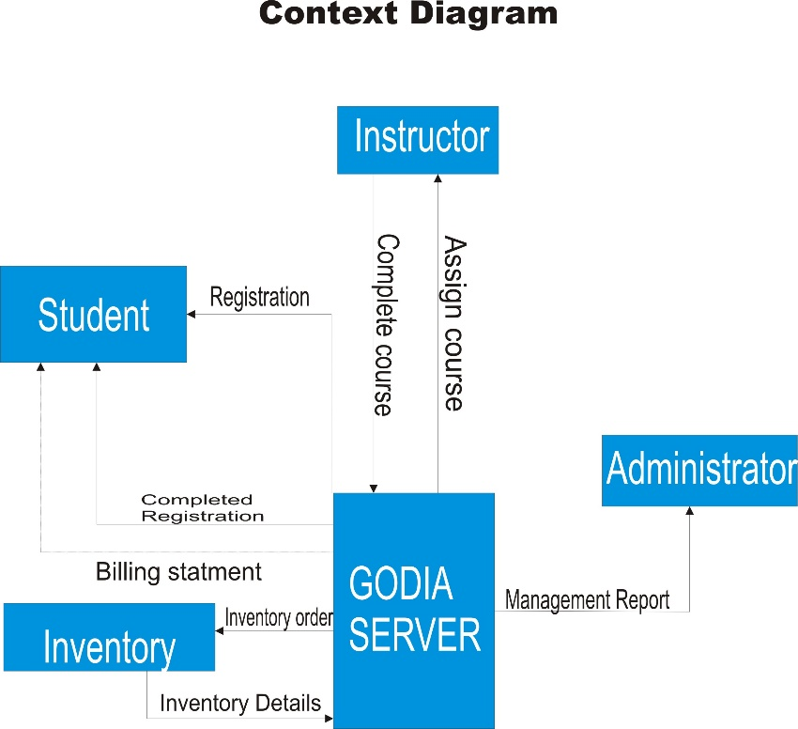

* 1. Identify major subsystems (level 0)

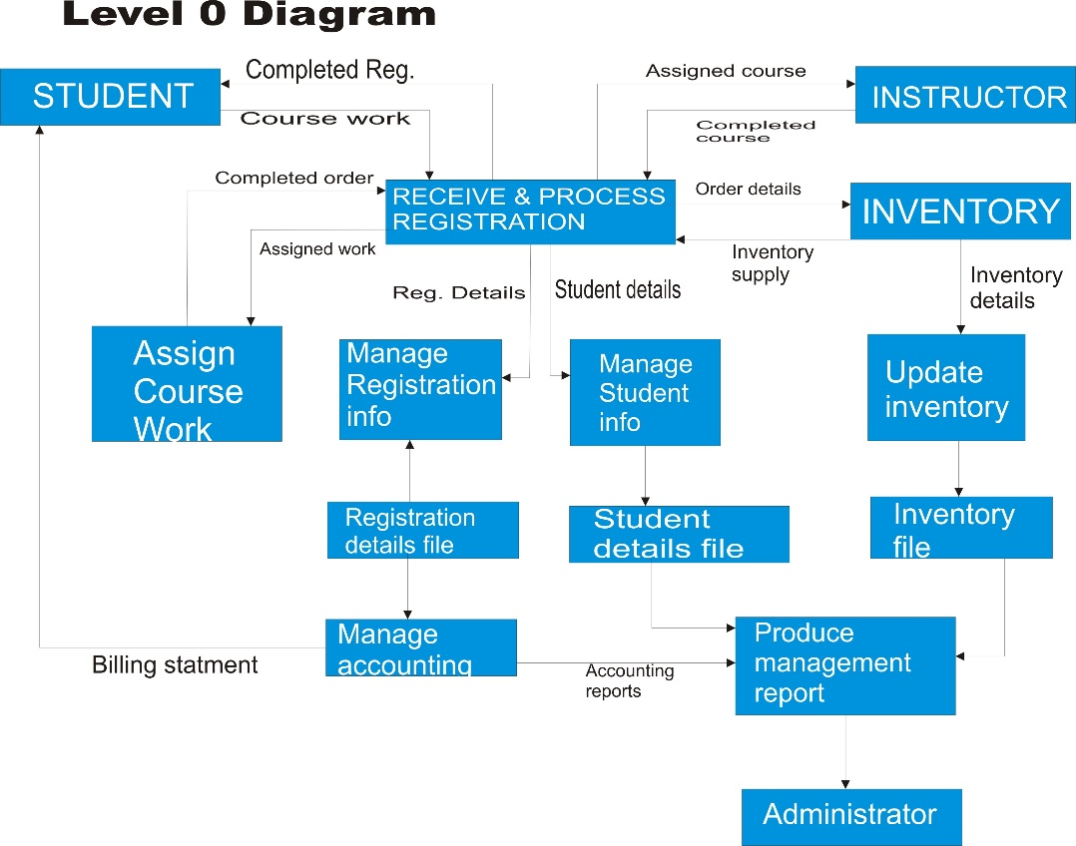

* 1. Expand a subsystem and identify process (business process)

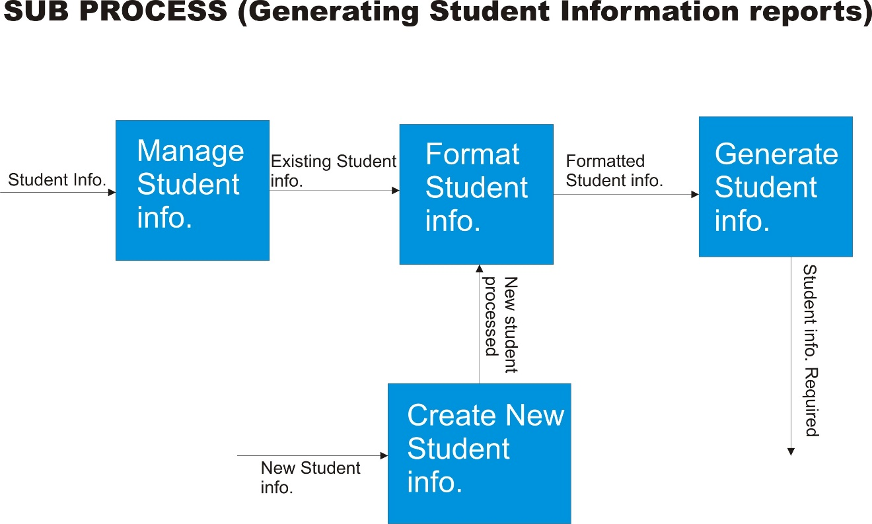

SECTION 4. DESIGN PHASE

* 1. ER diagram

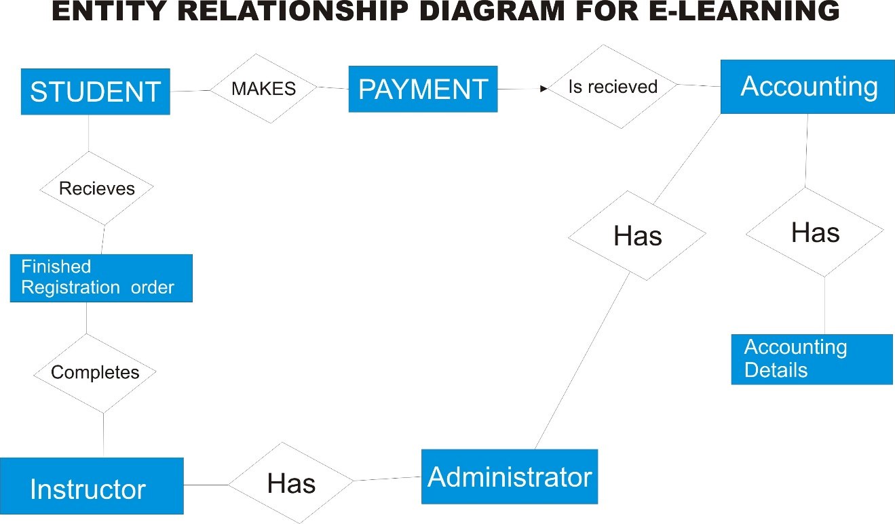

* 1. User case diagram

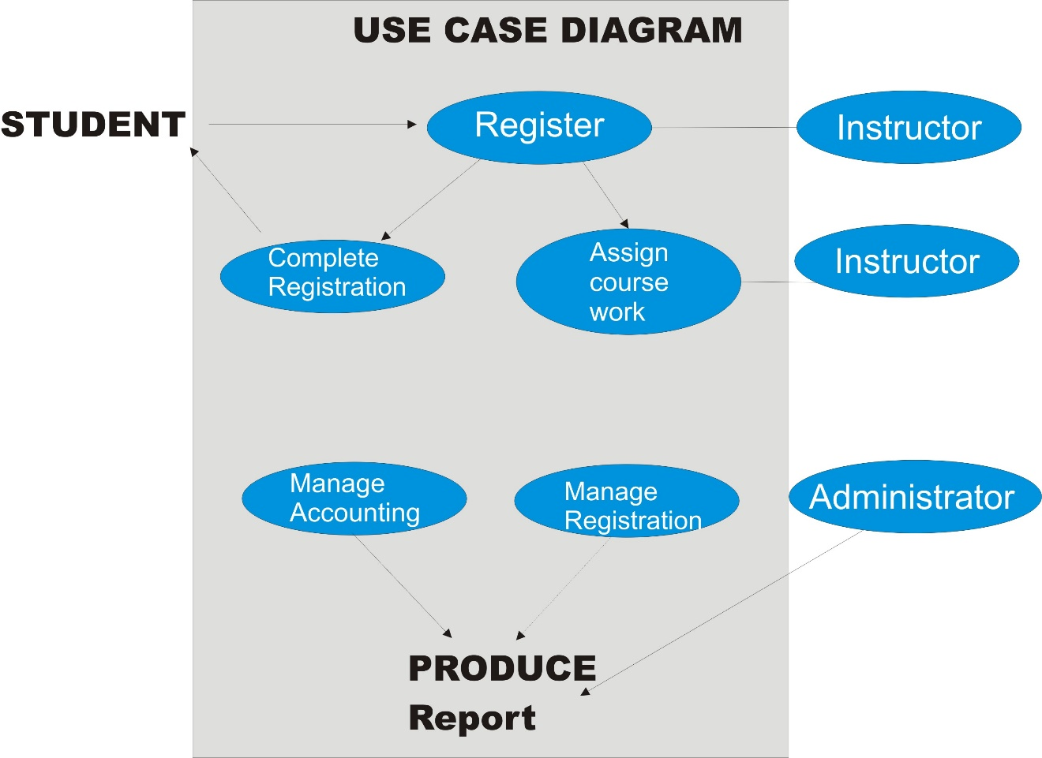

* 1. Database Schema

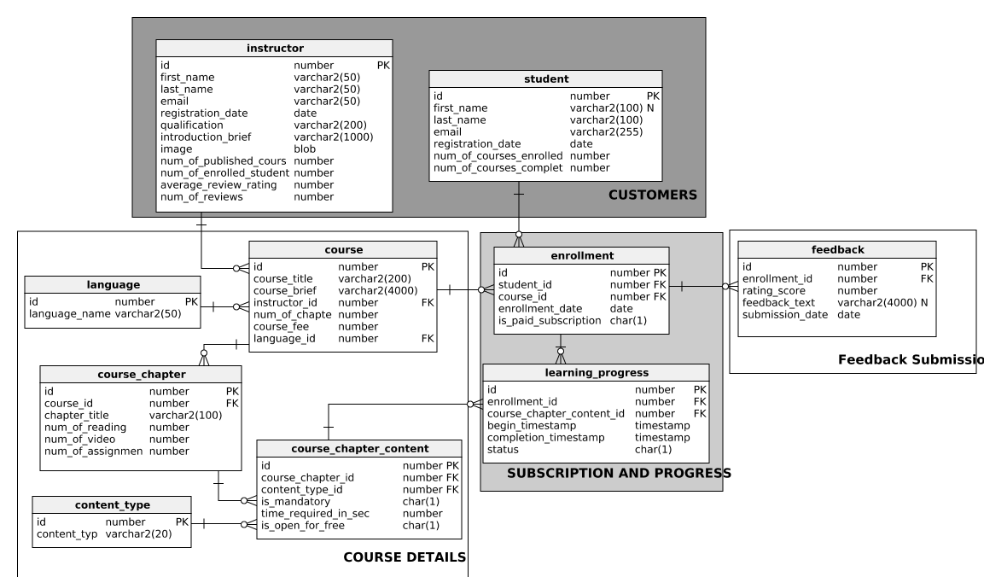

* 1. Graphical User Interface design

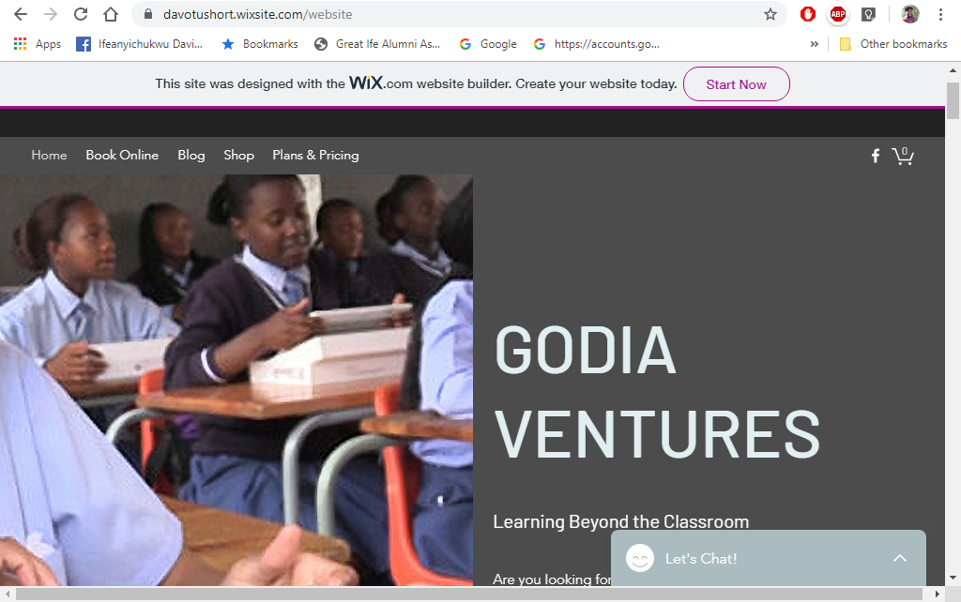

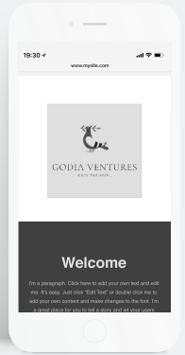

PROTOTYPE FORM

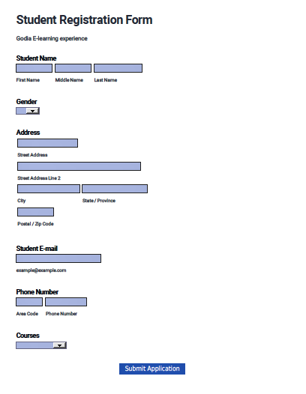

|  |  |  |  |  |  |  |
| --- | --- | --- | --- | --- | --- | --- |
| 4.5 Input / Output design | | | | | | |
| **Program: GODIA Ventures E Learning platform** | | | | | | |
| **Goal: Improve community members’ abilities to access quality, affordable education irrespective of geographical location.** | | | | | | |
| **INPUTS** | **ACTIVITIES** | | **OUTCOMES** | | | |
| **What we invest** | **What we do** | **Who we reach** | **Why this project: short-term results** | | **Why this project: intermediate results** | **Why this project: long-term results** |
| * Godia Staff * Instructors * Time * Money * Research * Study Materials * Equipment * Technology * Partners | * Digital learning * Face to face learning * Training * Develop products, curricula, resources * Facilitate access to information * Seminars and webinars | * Educators * Customers (Students) * Agencies and community-based organizations in Nigeria (CBOs) * Decision-makers (stakeholders) * Members of CBOs | *Learning*   * Increase the quality of knowledge * Change attitude towards learning * Provide skills * Provide resources | | *Action*   * Improve Decision-making * Improve test scores for national exams * Reach majority of rural communities | *Conditions*   * Increase quality of education * Achieve universal basic education * Reduce national illiteracy rate |
|  | | | | | | |
| Assumptions  * Adoption of E-learning will help reach the rural communities with quality educators. * Internet access has proliferated to every part of the country and most people own a smart phone which will give us great reach. | | | | External Factors  * Positive influences (Ease to use, cost effective) * negative influences (little Computer and technology use) * Culture, economics, politics, demographics | | |

SECTION 5. IMPLEMENTATION PHASE

The implementation of this system will be done through the following steps: Coding, Testing, Installation, User training, Maintenance and support.

**5.1 Coding phase**

This aspect is coordinated by the chief programmer who will schedule and start developing the system according to designs made in the previous phase of this project. The appearance and features of this system is discussed and how the end user will interact with this system. It is developed alongside testing to ensure code is working optimally and meets the purpose of design. The steps in the development are:

Recording of audio narration: Voice talent is given the script to make audio recordings and this is reviewed after it is received for corrections.

Design of content screen layout and interactive screen layout: The graphic designer makes a client approved design of both content and interactive screen layouts following eLearning style guide (e.g. Drag/Drop, Hot Spot, Labeling, Sequencing, etc.)

Design of quiz/assessment screen layout: Modified default quiz templates within authoring tool to conform to the eLearning style guide.

Assemble content screens with graphics and audio: Import and assemble all graphics and audio into the authoring tool. Synchronize the revealing/removing of graphics in timing with narration per storyboard.

Program the interactives: Import and assemble all graphics and audio into the authoring tool. Program the activity using built-in authoring tool features (variables, triggers, etc.), custom HTML5, and/or other techniques as required by storyboard and agreed to within the project scope of work.

Create assessment/ quiz: Apply quiz content from the storyboard to the built-in quiz functionality within the authoring tool. Apply graphics from graphic artist to ensure accurate look and feel.

**5.2 Testing:**

Testing is the primary step for evaluating compliance with requirements and ensure overall quality of project. An internal testing and external testing are scheduled. It is important the course be tested by someone outside of the development process. Create an "answer key" and "test script" to guide users as to how to stress test the course, confirm functionality, etc. The goal is to try and break the course or identify and correct errors before external review. Final review/sign-off authority should be done and provide feedback to the developers.

Testing is conducted at several levels.

***Component or Unit test:*** A component test is the test of an individual component of the solution. The objective of a component test is to ensure that the component correctly implements the design specifications.

***Assembly Testing:***

The assembly test verifies the interaction of related components to ensure that the components function properly when integrated. It occurs at multiple levels during the implementation of the project.

***Product (System) Testing:***

The product or system test ensures that all requirements have been met. Like the aforementioned tests, product testing may also occur at multiple levels. However, within these multiple levels, the purpose of testing is the same: to ascertain that the requirements have been met.

All phases of testing will be approached as follows:

**Develop test approach**: Provide the objectives, schedule, environment requirements, and entry and exit criteria for the test stage.

**Plan test**: Identify test conditions and test cycles for the test stage.

**Prepare test**: Define input data and expected results, scripts the test cycles, defines stubs and job streams, and prepares the cycle control calendar.

**Establish test environment**: Ensure the environment is established and tested before test execution.

**Execute test**: Perform the scripts contained in the test model, compares the actual results to the expected results, and identifies and resolves discrepancies.

**5.3 Hardware/Software installation plan**

The hardware installation occur before any software installation or configuration can take place. A SQL Server will need to be installed to host the system. An email server will need to be installed to filter communications from the system to staff email accounts. A SharePoint server will need to be installed in order to log and track issues. An intranet will be set up for the system. The portal will need to connect to the database and email server for customer notifications to take place. Sine portal platform will be provided by a Microsoft web server it will enable both locations to enter orders, view production schedules, track billing and orders. The intranet portal will be viewable and operable in both locations. The customer database and email server will be set up and connected to the order system to allow for customer notifications. Installing and configuring the new software solution will take a combination of the vendor, IT consultants and Godia staff. There will be a “live” system and a “test” system, which will be a duplication of the “live” system but where updates and enhancements can be tested before implementing into the “live” system. All training will also take place in the “test” system. Staff will be able to run test scenarios without harming vital customer and order data.

**5.4 User Training plan**

Effective end-user training is one of the keys to the successful implementation of any software.

Each end-user should gain the skill level required to test the course within the software so that they may more efficiently complete their tasks or process orders to the correct team to process.

Training will be done by Individual hands-on instructor, Computer based training using a training system and Training manuals provided for quick future reference.

**5.5 Go live checklist**

After the process of coding, testing, installation, we are ready to lunch the product.

Double check published settings including SCORM settings, course titles, learning object titles, scoring/completion criteria, etc.

***Pilot Test:*** It is recommended that courses be tested by a small group (10-20 users) of people who are representative of your target learner population. Consider giving 1/2 of the group a test script/answer key and require the other 1/2 to complete without the benefit of a job aid. Review and document any course improvements that may be required.

***Procedure Guides Complete:*** Verify that the procedures guide for each module has been completed and is easily accessible to all staff.

***Management Reports Complete****:* All management reports that were developed and any modifications have been completed.

*S****oftware Configuration Meets Business Needs****:* Verify that the software configuration meets Godia’s business needs. A high number of non-completions may indicate that there is a problem with the course tracking. If 100% score is required there may be a problem with a quiz question that is programmed incorrectly making it impossible to achieve 100%. Review and document any course improvements that may be required.

***Procedure for Contacting External IT Support is Defined:*** Godia will determine responsible person(s) that will be the primary decision makers in contacting the external IT Support consultants with telephone or in-person support, in order to limit unnecessary support requests. A support call log will be kept to record all calls, including the date, time, name of support representative contacted, issue and the outcome/solution.

***Client ID and Registration name are accessible:*** Your client ID and registration name should be accessible for future reference. Ensure that these are documented in an easily accessible location.

***Review User Satisfaction Surveys:*** Learners should be required to take a short satisfaction survey upon course completion. Review and document any course improvements that may be required.

**5.6 Maintenance plan**

In order to ensure that the system stays relevant and effectively handles the requirements Godia’s, there will be a periodic software evaluation plan after implementation. A maintenance team will be created to keep track of customer priorities, course completion and feedbacks.

Corrective maintenance occurs when a software module or feature fails to perform or process data correctly. Adaptive maintenance occurs when a change in the performance of the software causes a change in the hardware or overall software functionality. Perfective maintenance occurs when a company wants to modify the software to perform different or changing needs.

In order to reduce maintenance costs, we will complete a software system audit. If changes are requested and approved by management, a change request will be submitted to outline the proposed change. This will be discussed with management for approval or rejection based upon the amount of effort and cost the change will take to develop and implement.

Version control will be well documented, outlining and managing the revisions to the original software design, features and documentation. Changes will be identified with a code, known as the revision number.

**5.7 Future Improvement**

**Short-term – first 12 months**

* Optimization of reports to serve all account, course registered, inventory, customer service, and business management needs.
* Creation of portal homepage performance dashboard to visualize student performance metrics, registration goals, and opportunities for improvement.
* Head of IT at GODIA will repeat the software configuration analysis three, six, and twelve months after initial implementation to identify any adaptive or perfective measures needed to meet business needs.

**Long-term – 12 months and after**

* In order to be more competitive in the market, GODIA ventures would offer more and better custom designs and improve application functions; therefore, exploration and evaluation of a new artwork and production management system will be scheduled.

**5.8 Lessons Learned**

* Build in more time for employee interviews when an organization is starting e-learning platform from scratch.
* Ask about hiring plans during interviews to correctly allot training needs.
* User interface designers are worth the investment since usability and adoption improve with more intuitive design.
* Hold a third day of training to lessen support calls and improve adoption.
* Follow up after implementation with ad hoc on-the-job training to keep satisfaction high and maintain usage.
* Follow up with owners regularly via phone and in-person to check in on usage, satisfaction, and errors.
* Project go-live hit the scheduled launch date, so project schedule was a good estimate for length of time to complete this type of project.
* Build in extra cushion for server costs in case actual costs exceed estimates.
* Always test codes as it is being written to avoid malfunctions when it is finally lunched.